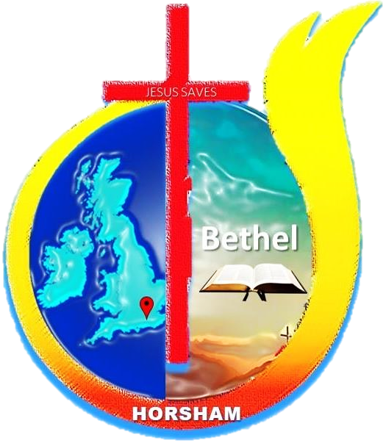
Bethel Church of God, Horsham

About: A Pentecostal community, multi-lingual church pronominally from Southern India, but we serve all communities; if you are looking for a spiritual family for fellowship, friendship, prayer, and a place of worship, we gladly welcome you to come along and be part of our congregation.
We believe: Jesus Christ is the only begotten Son of God. Being in the very nature, God came down to this world as flesh, to die on the cross for our redemption. Christ paid the price for our sins and has given us eternal hope and the right to be called children of God. Our sins brought us condemnation and distanced us from our holy Creator and loving God, but through the blood of Jesus Christ cleanses and purifies us of our sin, we are brought back to the love of the Father. And so we gather together to worship and exalt his holy name in spirit and truth.
When: We meet for the Sunday church at the Brighton Road Baptist Church, from 3 Pm to 5 Pm; other fellowships are currently on Zoom.
Contact:
Please get in touch with us on to find out more.
TEL: 07456 277615
Email: bethelcoghorsham@gmail.com
Follow and contact us on the Bethel COG Horsham Facebook page: https://www.facebook.com/Bethel-COG-Horsham-103617928099903/
Church of God Malayalam Website: https://cogmalayalam.co.uk/horsham-church-of-god- Church of God UK & EU (Malayalam Section) is a growing part of the UKCCM (UK Cross-Cultural Ministries) and part of the International Church of God (Cleveland TN).

